Name | Class | Roll | Class Rank | Mother's Name | Father's Name | Pictuer
FARISTA HAKIM SINTHIYA | Play | 03 | 02 | SHARMIN AKTER | ABDUL HAKIM TUHIN | 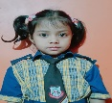
TASBIH AFRA | Nursery | 39 | 01 | MANZIDA KHANOM BIPASHA | TARAQ MAHMUD | 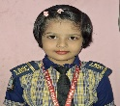
NURUSSAPA ISLAM ABID | One | 01 | 01 | KURSHIDA BEGUM | MD NURUL KADER | 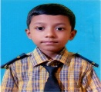
UMME RAIFA RUHI | Two | 01 | 01 | ROSY AKTER | MD. RUBEL | 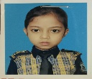
MD ISTIAQ HASAN | Three | 41 | 01 | SHARMIN AKTER | MD IDRIS | 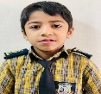
MST NOWSHIN AKTHER | Four | 01 | 02 | JERINA AKTHER JONY | MD RAFIQ | 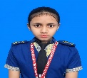
OISHE BARUA | Five | 01 | 01 | RUMI BARUA | JUNTO BARUA | 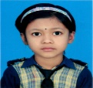
AFRIDA NUR ALVINA | Six | 01 | 01 | KHURSHIDA BEGUM | MD NURUL KADER | 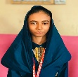
AYATUN NAHAR ORPA | Seven | 04 | 01 | AFROJA SULTANA | MD ALAMGIR HUSSAIN | 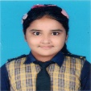
SADIKA AKTER RICHI | Eight | 01 | 01 | JOSNA AKTER | MD. ALI | 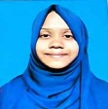
FARHAN NAKIB SHABIB | Nine | 55 | 01 | HUSNUR HURINE | SAYED MOHAMMAD SHAJALAL FARUQUE | 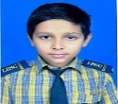
MD ARIAN ISLAM RASEL | Ten | 01 | 01 | MST SWAPNA BEGUM | MD EJAJUL ISLAM | 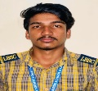
Best Student Award 2026

